HD IR Waterproof Fixed Network Camera Quick Start Guide

Version 1.0.1
Zhejiang Dahua Technology CO., LTD
Welcome
Thank you for purchasing our network camera!
This quick start guide is designed to be a reference tool for your system.
Please keep this start guide well for future reference.
Please open the accessory bag to check the items one by one in accordance with the list below. Contact your local retailer ASAP if something is missing or damaged in the bag.

Before your operation please read the following instructions carefully.
1．Electrical safety
All installation and operation here should conform to your local electrical safety codes.
The power shall conform to the requirement in the SELV (Safety Extra Low Voltage) and the Limited power source is rated 12V DC or 24V AC in the IEC60950-1. (Refer to general introduction) Please note: Do not connect two power supplying sources to the device at the same time; it may result in device damage! The product must be grounded to reduce the risk of electronic shock.
We assume no liability or responsibility for all the fires or electrical shock caused by improper handling or installation.
We are not liable for any problems caused by unauthorized modification or attempted repair.

2．Transportation security
Heavy stress, violent vibration or water splash are not allowed during transportation, storage and installation.

3．Installation
Do not apply power to the camera before completing installation.
Please install the proper power cut-off device during the installation connection.
Always follow the instruction guide the manufacturer recommended.

4．Qualified engineers needed
All the examination and repair work should be done by the qualified service engineers.
We are not liable for any problems caused by unauthorized modifications or attempted repair.

5．Environment
This series network camera should be installed in a cool, dry place away from direct sunlight, inflammable, explosive substances and etc.
Please keep it away from the electromagnetic radiation object and environment.
Please make sure the CCD (CMOS) component is out of the radiation of the laser beam device. Otherwise it may result in CCD (CMOS) optical component damage.
Please keep the sound ventilation.
Do not allow the water and other liquid falling into the camera.
Thunder-proof device is recommended to be adopted to better prevent thunder.
The grounding studs of the product are recommended to be grounded to further enhance the reliability of the camera.

6. Daily Maintenance
Please shut down the device and then unplug the power cable before you begin daily maintenance work.
Do not touch the CCD (CMOS) optic component. You can use the blower to clean the dust on the lens surface.
Always use the dry soft cloth to clean the device. If there is too much dust, please use the water to dilute the mild detergent first and then use it to clean the device. Finally use the dry cloth to clean the device.
Please put the dustproof cap to protect the CCD (CMOS) component when you do not use the camera.
Dome enclosure is the optical component, do not touch the enclosure when you are installing the device or clean the enclosure when you are doing maintenance work. Please use professional optical clean method to clean the enclosure. Improper enclosure clean method (such as use cloth) may result in poor IR effect of camera with IR function.

7. Accessories
Be sure to use all the accessories recommended by manufacturer.
Before installation, please open the package and check all the components are included.
Contact your local retailer ASAP if something is broken in your package.

Accessory Name | Amount
Network Camera Unit | 1
Quick Start Guide | 1
CD | 1
Warranty Card and Certificate | 1

Table of Contents
1 Structure 1
1.1 Multiple-function Combination Cable 1
1.2 Framework and Dimension 2
1.3 Bidirectional talk 3
1.3.1 Device-end to PC-end 3
1.3.2 PC-end to the Device-end 3
1.4 Alarm Setup 4
2 Device Installation 6
2.1 Installation 6
2.2 Adjust Lens and Install SD Card 6
2.3 Bracket Adjustment 7
3 Quick Configuration Tool 9
3.1 Overview 9
3.2 Operation 9
4 Web Operation 11
4.1 Network Connection 11
4.2 Login and Main Interface 11
Appendix Toxic or Hazardous Materials or Elements 13

Structure

Multiple-function Combination Cable
Note:
Figures in this chapter are for reference only, and different models use different figures, please select a or b model accordingly.
You can refer to the following figure for cable information. See Figure 1-1 and Figure 1-2.
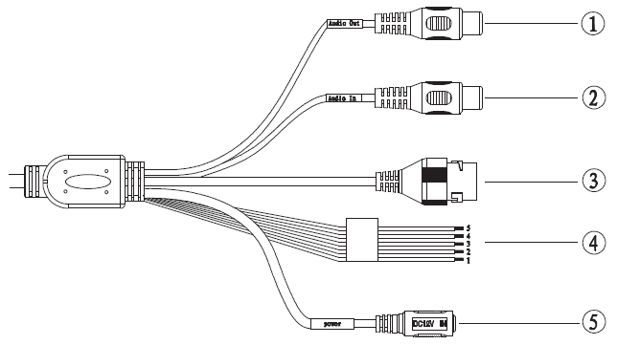
Figure 1-1 Multiple-function combination cable a
Please refer to the following sheet for detailed information.
SN | Port Name | Function | Connection | Note
1 | AUDIO OUT | Audio output port | RCA | Output audio signal to the devices such as the sound box.
2 | AUDIO IN | Audio input port | RCA | Input audio signal. It can receive the analog audio signal from the pickup.
3 | LAN | Network port | Ethernet port | - Connect to standard Ethernet cable.
4 | I/O | I/O cable port | / | Includes alarm input and output.
5 | POWER | Power input port | / | Power port. Input DC 12V or AC 24V.  Please note：  Connect the DC5.5 round port to 2-pin converter cable (Provided) when you are using AC 24V series product.  Please use according to device tag.

Please refer to the follow sheet for detailed pin information.
Port Name | SN | Name | Note
I/O Port | 1 | ALARM_NO | Alarm output port. It is to output the alarm signal to the alarm device.  NO: normal open alarm output port.  This port shall be used with ALARM_COM port.
I/O Port | 2 | ALARM_COM | Alarm output public port.
I/O Port | 3 | ALARM_IN1 | Alarm input port 1. It is to receive the on-off signal from the external alarm source.
I/O Port | 4 | ALARM_IN2 | Alarm input port 2. It is to receive the on-off signal from the external alarm source.
I/O Port | 5 | GND | Ground port

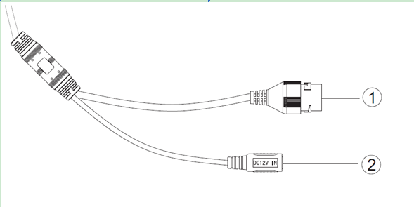
Figure 1-2 Multiple-function combination cable b

Please refer to the follow sheet for detailed pin information.
Port | Port Name | Note
1 | Network Port | Network data input/output and PoE.
2 | Power Input Port | Connect to DC 12V, input power

Framework and Dimension
Please refer to the following two figures for dimension information. The unit is mm. See Figure 1-3 and Figure 1-4.
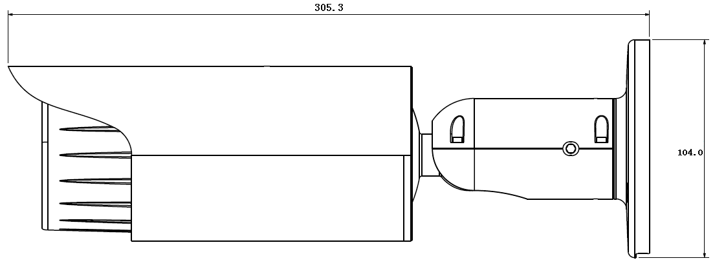
Figure 1-3 Dimension illustration 1
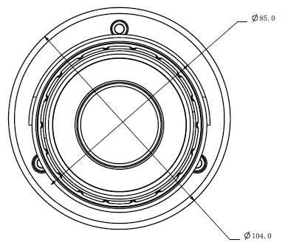
Figure 1-4 Dimension illustration 2

Bidirectional talk

Device-end to PC-end
Device Connection
Please connect the speaker or the MIC to the audio input port of the device. Then connect the earphone to the audio output port of the PC.
Login the Web and then click the Talk button to enable the bidirectional talk function.
You can see the button becomes orange after you enabled the bidirectional talk function.
Click Talk button again to stop the bidirectional talk function.
Listening Operation
At the device end, speak via the speaker or MIC, and then you can get the audio from the earphone or sound box at the pc-end.

PC-end to the Device-end
Device Connection
Connect the speaker or the MIC to the audio input port of the PC and then connect the earphone to the audio output port of the device.
Login the Web and then click the Talk button to enable the bidirectional talk function.
You can see the button becomes orange after you enabled the audio talk function.
Click Talk button again to stop the bidirectional talk function.
Please note the on-site listening operation is null during the bidirectional talk process.
Listening Operation
At the PC-end, speak via the speaker or MIC, and then you can get the audio from the earphone or sound box at the device-end.

Alarm Setup
The alarm interface is shown as in Figure 1-5. Please follow the steps listed below for local alarm input and output connection.
1) Connect the alarm input device to the alarm input port (No.3 pin or No.4 pin) of the I/O cable.
2) Connect the alarm output device to the alarm output port (No.2 pin) and alarm output public port (No.1 pin). The alarm output port supports NO (normal open) alarm device only.
3) Open the Web, go to the Figure 1-5. Please set the alarm input 01 port for the first channel of the I/O cable (No.3 pin). The alarm input 02 is for the 2nd channel of I/O cable (No.4 pin). Then you can select the corresponding type (NO/NC.)
4) Set the WEB alarm output. The alarm output 01 is for the alarm output port of the device. It is the No.2 pin of the I/O cable.
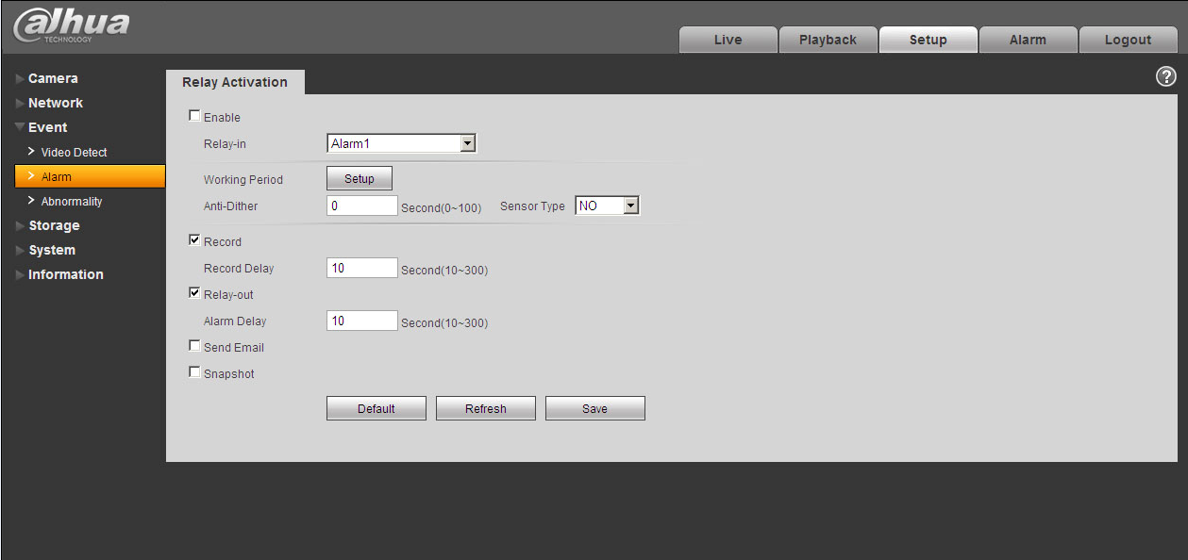
Figure 1-5 Alarm
Please refer to the following figure for alarm input information. See Figure 1-6.
Alarm input: When the input signal is idle or grounded, the device can collect the different statuses of the alarm input port. When the input signal is connected to the 5V or is idle, the device collects the logic “1”. When the input signal is grounded, the device collects the logic “0”.
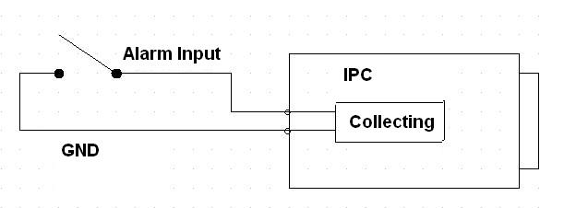
Figure 1-6 Alarm input

Please refer to the following figure for alarm output information. See Figure 1-7.
Port NO and Port C composes an on-off button to provide the alarm output.
If the type is NO, this button is normal open. The button becomes on when there is an alarm output.
If the type is NC, this button is normal off. The button becomes off when there is an alarm output.
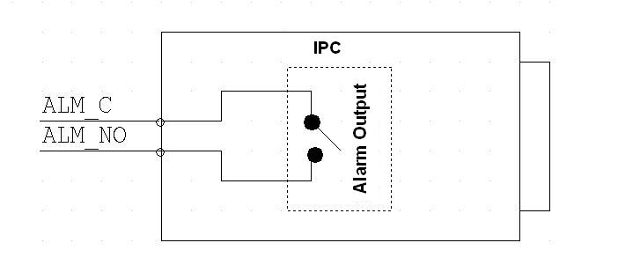
Figure 1-7 Alarm output

Device Installation

Installation
Please follow the steps listed below to install the device. Please refer to Figure 2-8 for reference.
- On installation surface, mark hole for bracket installation and insert three expansion bolts on installation surface. Push the three expansion bolts into the installation holes and fasten them.
- Aim the three screw holes on bracket bottom at three installation holes on installation surface. Insert the three set screws into the three screw holes on bracket bottom one by one. Fix bracket on installation surface.
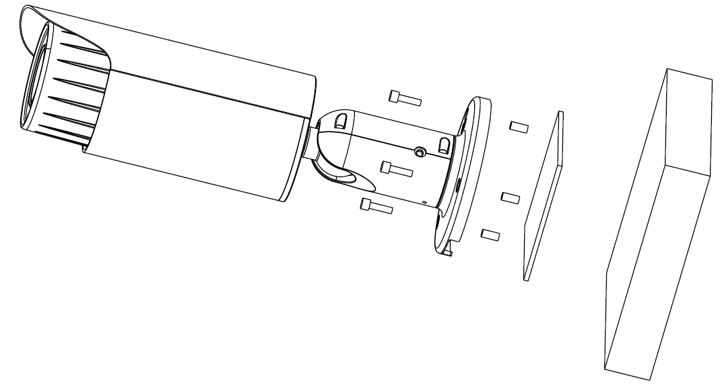
Figure 2-8 Device installation illustration

Adjust Lens and Install SD Card
Rotate lens cover counterclockwise and remove it to view lens, SD card, buttons and reset.
Note:
- If you cannot rotate lens cover, you can take down sunshade first and try again.
- Lens cover is part of device waterproof system, please fasten it when you finish adjustment.
- Motorized focus series device has motorized focus lens, no need of manual adjustment by default, meantime support five adjustment buttons. Manual focus series device has manual focus lens which shall be adjusted according to actual need. See Figure 2-2.

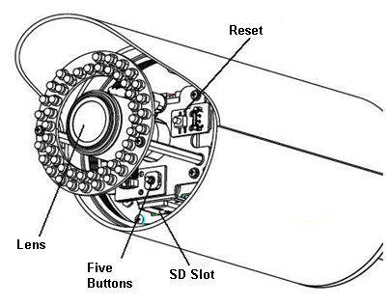
Figure 2-9 Lens

Bracket Adjustment
You can adjust bracket via a M4 inner hex wrench. Before adjustment, you shall loosen screw via inner hex wrench in accessories bag, and rotate rear cover 360° horizontally, rotate 90° vertically. Rotate pedestal 360°.
Fasten screw via inner hex wrench.
Note:
M4 inner hex wrench must be fastened, if not, you will not be able to fix the device to a specific position.

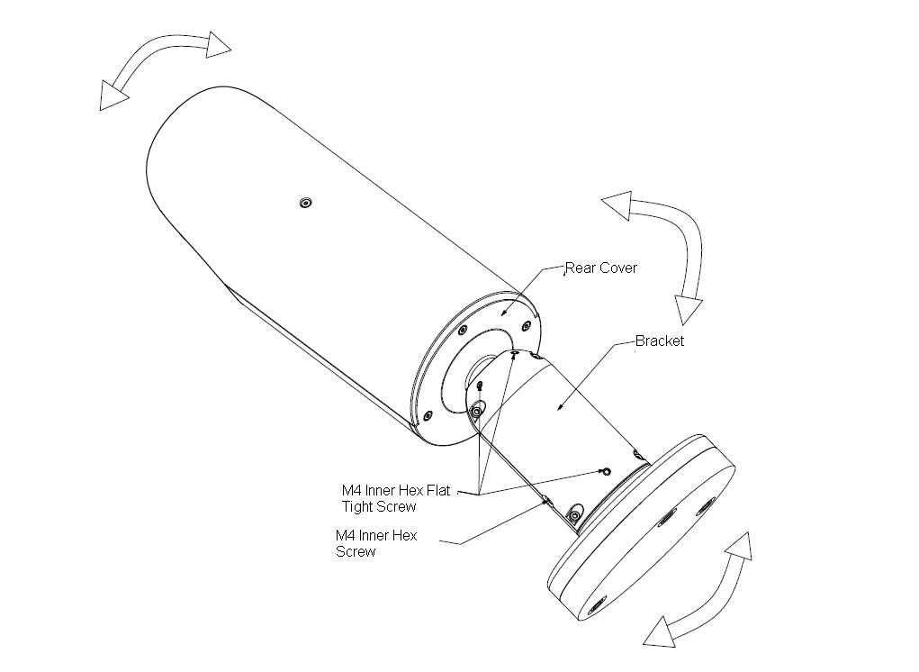
Figure 2-10 Bracket

Quick Configuration Tool

Overview
Quick configuration tool can search current IP address, modify IP address. At the same time, you can use it to upgrade the device.
Please note the tool only applies to the IP addresses in the same segment.

Operation
Double click the “ConfigTools.exe” icon, you can see an interface is shown as in Figure 3-11.
In the device list interface, you can view device IP address, port number, subnet mask, default gateway, MAC address and etc.
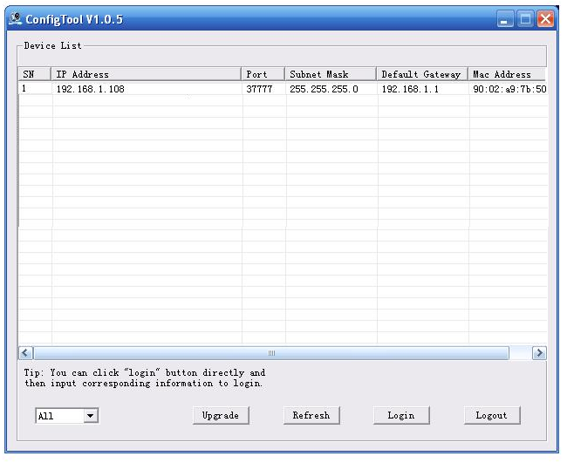
Figure 3-11 Search interface
Select one IP address and then right click mouse, you can see an interface is shown as in Figure 3-12.
Select the “Open Device Web” item; you can go to the corresponding web login interface.
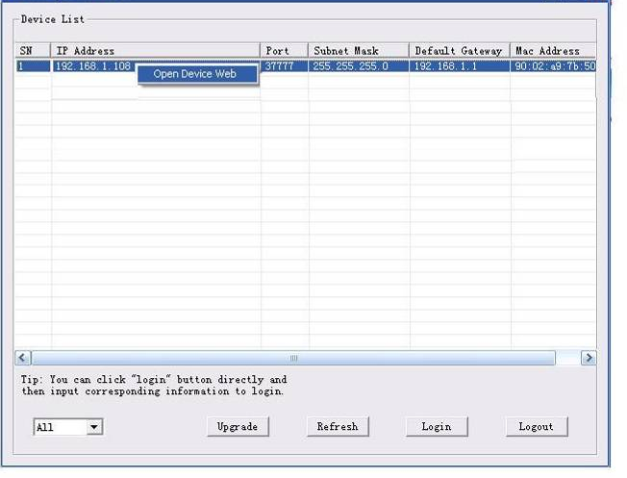
Figure 3-12 Search interface 2

If you want to modify the device IP address without logging in the device web interface, you can go to the configuration tool main interface to set.
In the configuration tool search interface (Figure 3-11), please select a device IP address and then double click it to open the login interface. Or you can select an IP address and then click the Login button to go to the login interface. See Figure 3-3.
In Figure 3-3, you can view device IP address, user name, password and port. Please modify the corresponding information to login.
Please note the port information here shall be identical with the port value you set in TCP port in Web Network interface. Otherwise, you cannot login the device.
If you are using device background upgrade port 3800 to login, other setups are all invalid.
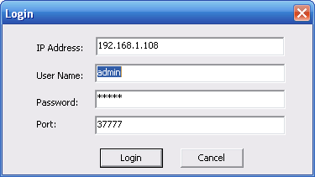
Figure 3-3 Login prompt
After you logged in, the configuration tool main interface is shown as below. See Figure 3-4.
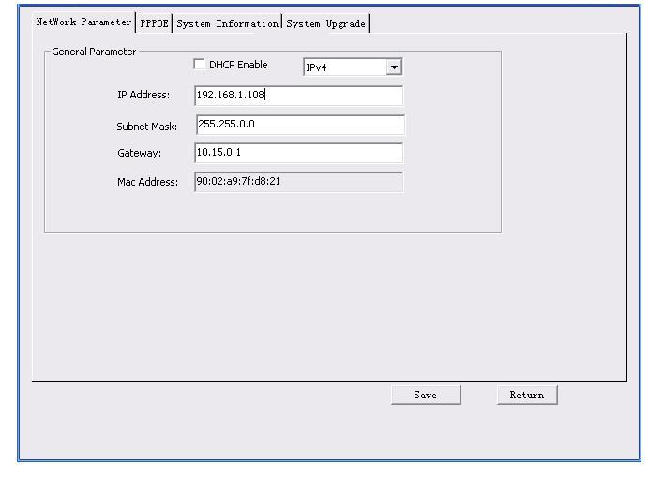
Figure 3-4 Main interface
For detailed information and operation instruction of the quick configuration tool, please refer to the Quick Configuration Tool User’s Manual included in the resources CD.

Web Operation
This series network camera products support the Web access and management via PC.
Web includes several modules: Monitor channel preview, system configuration, alarm and etc.

Network Connection
Please follow the steps listed below for network connection.
- Make sure the network camera has connected to the network properly.
- Please set the IP address, subnet mask and gateway of the PC and the network camera respectively. Network camera default IP address is 192.168.1.108. Subnet mask is 255.255.255.0. Gateway is 192.168.1.1
- Use order ping ***.***.***.***(* network camera address) to check connection is OK or not.

Login and Main Interface
Open IE and input network camera address in the address bar. See Figure 4- .

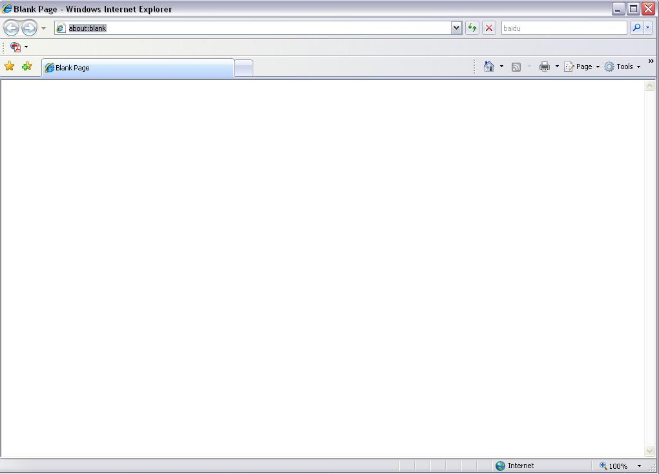
Input your IP address here
Figure 4- IP address
The login interface is shown as below. See Figure 4- .
Please input your user name and password.
Default factory name is admin and password is admin.
Note: For security reasons, please modify your password after you first login.

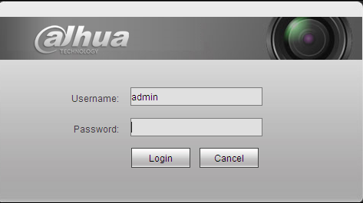
Figure 4- Web login
After you successfully logged in, please install WEB plug-in unit. Please refer to the Web Operation Manual included in the resource CD for detailed operation instruction.
See Figure 4- .

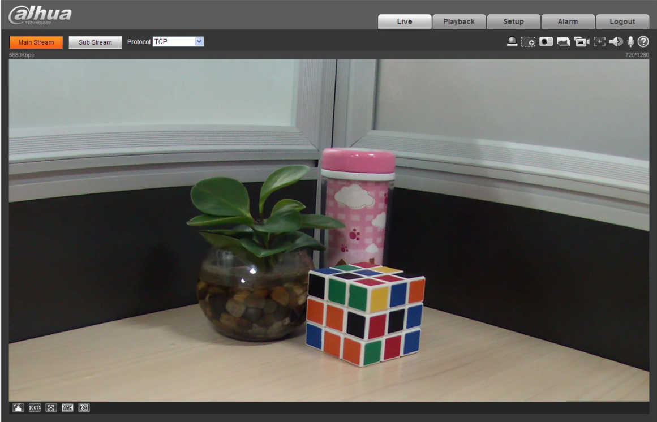
Figure 4- Web monitoring window

Appendix Toxic or Hazardous Materials or Elements
Component Name | Toxic or Hazardous Materials or Elements
Component Name | Pb | Hg | Cd | Cr VI | PBB | PBDE
Circuit Board Component | ○ | ○ | ○ | ○ | ○ | ○
Device Construction Material | ○ | ○ | ○ | ○ | ○ | ○
Wire and Cable | ○ | ○ | ○ | ○ | ○ | ○
Packing Components | ○ | ○ | ○ | ○ | ○ | ○
Accessories | ○ | ○ | ○ | ○ | ○ | ○

O: Indicates that the concentration of the hazardous substance in all homogeneous materials in the parts is below the relevant threshold of the SJ/T11363-2006 standard.

X: Indicates that the concentration of the hazardous substance of at least one of all homogeneous materials in the parts is above the relevant threshold of the SJ/T11363-2006 standard. During the environmental-friendly use period (EFUP) period, the toxic or hazardous substance or elements contained in products will not leak or mutate so that the use of these (substances or elements) will not result in any severe environmental pollution, any bodily injury or damage to any assets. The consumer is not authorized to process such kind of substances or elements, please return to the corresponding local authorities to process according to your local government statutes.

Note
- This user’s manual is for reference only. Slight difference may be found in user interface.
- All the designs and software here are subject to change without prior written notice.
- If there is any uncertainty or controversy, please refer to the final explanation of us.
- Please visit our website for more information.
- All trademarks and registered trademarks are the properties of their respective owners.



Zhejiang Dahua Vision Technology CO.,LTD.
Address：No.1199 Bin’an Road, Binjiang District, Hangzhou, PRC.
Postcode: 310053
Tel: +86-571-87688883
Fax: +86-571-87688815
Email:overseas@dahuatech.com
Website: www.dahuatech.com

